**Biography**

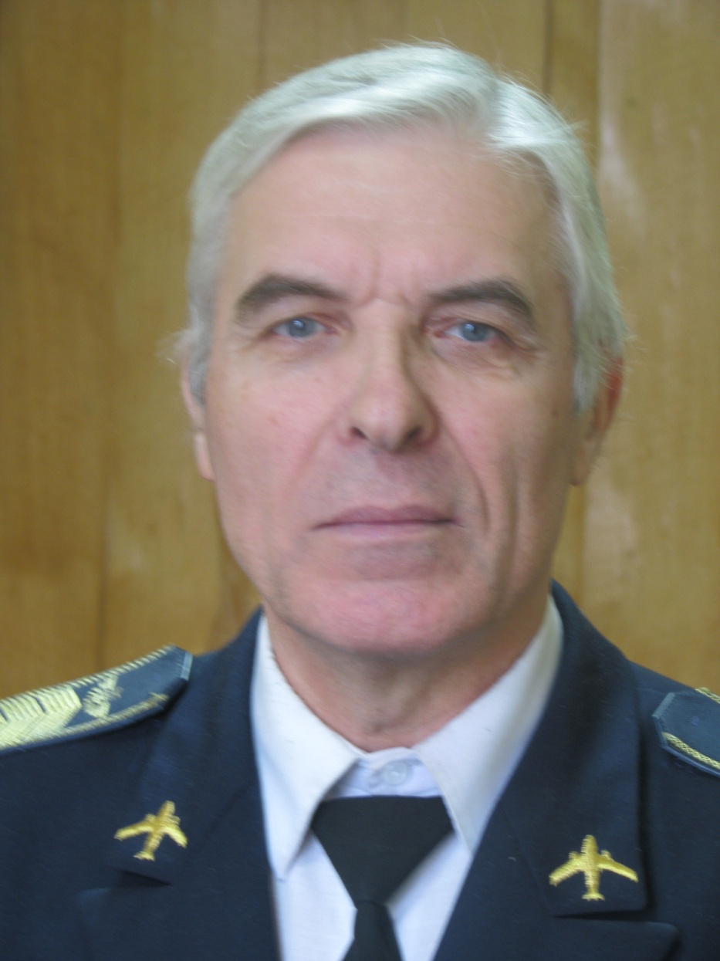

1) Photo

2) Full Name – Petro O. Kondratenko

3) Position - Professor of the Department of General and Applied Physics of ACF NAU

4) Scientific degree, academic title - Doctor of Physical and Mathematical Sciences. Professor, Honored Worker of Science and Technology of Ukraine.

5) Biography (short):

Petro O. Kondratenko was born on January 3, 1944.

In 1967 he graduated from the Faculty of Physics of the Shevchenko Kyiv State University. specialty "Optics and spectroscopy", qualification of physicist-optician.

From 1967 to 1970 he studied in graduate school at the Department of Optics, Physics Department, Shevchenko Kyiv State University under the guidance of Doctor of Physical and Mathematical Sciences, Professor (later Academician of NAS of Ukraine) Gorban I.S.

He worked at the Institute of Physics of the NAS of Ukraine from 1970 to 1992 as senior engineer (1970-1973), junior researcher (1973-1978), senior scientist (1978-1989) and leading researcher (1989-1992), department of molecular photoelectronics.

From 1992 to 2006 he worked at the Supreme Attestation Commission of Ukraine as the Head of the Natural Sciences Department.

Since 2003 he is Professor of the Department of Theoretical Physics in addition to other duties. Since 2006 he moved to a full-time job at the National Aviation University as a Professor of the Department of Theoretical Physics of the Mechanical-Energy Faculty of the Aerospace Institute of the National Aviation University. In 2007-2013 - Head of the same department, from 2013 to the present time -. Professor of the Department of Theoretical (now General) and Applied Physics.

In 1972 he defended his thesis "Research of coloring of single crystals of corundum" for the degree of candidate of physical and mathematical sciences in the specialty "optics".

In 1989 he defended his dissertation "Photoprocesses in diazonium salts and related compounds, as well as in recording media based on them" for the degree of Doctor of Physical and Mathematical Sciences in the specialty "optics".

He is Senior Scientist Researcher in the field of solid state physics (1984), Professor in the field of optics (1992). In 2001 he was awarded the title "Honored Worker of Science and Technology of Ukraine" for outstanding scientific achievements. He was awarded the Medal "In Memory of the 1500th Anniversary of Kyiv" (1983) and the thanks of the Head of the Kyiv City Council (2002).

6) Professional and scientific interest

Scientific studies are related to the study of scientific problems in solid-state optics, molecular systems physics, universe physics, and hierarchy of physical fields. He is the author of more than 350 scientific works, of which - 30 copyrighted certificates for inventions, 6 manuals, 2 monographs.  
As a result of experimental and theoretical studies on solid-state optics and molecule physics:  
1. One-act manifestation of dissociation of a molecule into several fragments is revealed in the case when the dissociating molecule forms strong associates with the participation of several n-orbitals with molecules of a certain nature. 2. Mechanisms of dissociation of Xe-O bond molecules between fragments (diazonium salts, azides, etc.) have been identified. 3. A generalized theory of molecular diffusion in inhomogeneous polymer layers and experimental realization of spatial inhomogeneity of polymer layers are developed. 4. The theory of dependence of the dielectric constant of a substance on distance (at short distances) is developed and the role of electrostatic interaction in the association of impurities in solid solutions is explained. 5. The existence of dislocation excitons is shown experimentally. 6. A method of investigation of dislocation diffusion in molecular crystals is developed and the determining role of dislocation diffusion in the processes of sublimation of crystals at temperatures below the melting point is shown. 7. Mechanisms of one- and two-quantum photostability processes of dye molecules in solid and liquid solutions have been found. 8. Molecular switches and molecular transistors have been developed as elements of electronic computer systems. 9. The relaxation processes of molecules from excited states are studied and it is proved that these processes proceed by a quasi-equilibrium mechanism.

10. A new concept of physical fields in the Universe is proposed. 11. A new model for the creation of the Universe is proposed, which is characterized by minimal initial entropy and cold matter. 12. Models have been developed that explain the mechanisms of strong and weak interaction in the microcosm. 13. Mechanisms for creating planetary and multiple star systems developed within the framework of the proposed model. 14. A scalar field responsible for the creation of substances in the universe and for the processes of particle annihilation is introduced. 15. The model of creation of spiral galaxies is developed. 16. The model of creation of the Solar system is developed. 17. Mechanisms of birth of matter in the universe have been developed. 18. The molecular structure of atomic nuclei is developed. 19. The evolution of the Universe is considered as the brane of four-dimensional space. 20. The initial period in the creation of the universe is detailed.

7) Contact e-mail: [pkondrat@ukr.net](mailto:pkondrat@ukr.net); [pkondrat@nau.edu.ua](mailto:pkondrat@nau.edu.ua)

8) Location in NAU – building 1, cabinet 1.426.

9) List of subjects taught:

1.General physics (for engineers)

2. Oscillations and waves. Optics

3. Physics of semiconductors

4. Fundamentals of scientific research